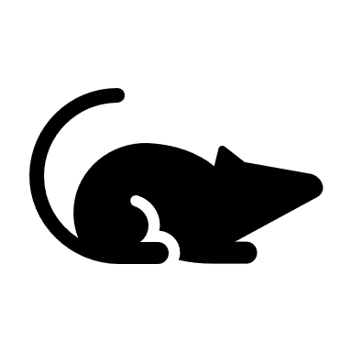



For reasonable accommodations or alternative formats please contact the Minneapolis Heath Department at 612-673-2301 or [covid19@minneapolismn.gov](mailto:covid19@minneapolismn.gov). People who are deaf or hard of hearing can use a relay service to call 311 at 612-673-3000. TTY users can 612-263-6850. Para asistencia 612-673-2700, Yog xav tau kev pab, hu 612-673-2800, Hadii aad Caawimaad u baahantahay 612-673-3500.

**For more information, visit** [**http://www2.minneapolismn.gov/coronavirus/vaccines**](http://www2.minneapolismn.gov/coronavirus/vaccines)

An emergency use authorizationrequires review and approval by the Food and Drug Administration (FDA). The FDA reviews all available scientific data to determine that the vaccine is safe and effective before approving.

In Minnesota, vaccinations began in mid-December 2020.

**COVID -19 Vaccine Development and Approval**

**Vaccine Approval Process**